**Expanding Data Visualisation to the Realm of Augmented Reality**

**Matt Gray**

**Abstract**

Data analysis and visualisation is an integral part of how every industry evaluates their effectiveness with their audiences and is a large industry in itself. New mediums allow for changes in the way we view and analyse data and one of the more prominent technological advances in recent years is the accessibility of Virtual Reality and Augmented Reality. The expansion of these technologies has allowed for the way we view data to change and the understanding of that data to be easier for users. This study examines the ways in which the change to an interactive three-dimensional view can revolutionise the way we experience data and assist data analysts with their understanding of the data they view in multiple levels of detail.

**Keywords**

Virtual Reality, Augmented Reality, Data Visualisation, Data Analysis, HoloLens, Unity Game Engine, Categorical, Longitudinal

**Introduction**

Data analysis is used in every industry to some degree, Shamoo and Resnik state that data analysis provides ‘a way of drawing inductive inferences from data and distinguishing the signal (the phenomenon of interest) from the noise (statistical fluctuations) present in the data’. (Shamoo & Resnik, 2009) Therefore, it is in data analysists interests to develop efficient visualisation solutions to easily sort, view and understand the data gathered. The development of visualisation tools for data analysis is an industry in itself and many advances have already been made in regard to static, non-immersive environments and 2D solutions with; charts, graphs, particle systems and various sorting options for each. However, with recent developments of Virtual Reality(VR), Augmented Reality(AR) and Mixed Reality(MR), there is the opportunity to develop new visualisation tools for these immersive 3D environments.

VR, AR and MR offer users the ability to experience an environment through a headset or interactive device, this allows for a dynamic viewing experience where users can view the data from any direction or orientation allowing for greater use of the advantages that three dimensions allow. VR enables users to view environments and information in an entirely virtual environment while AR and MR allow users to combine the real-world environment with the virtual environment. This paper will discuss a solution using MR through a headset known as the Microsoft HoloLens. The HoloLens was chosen for its ability to spatially map surfaces in the real world in real time developing a complex virtual mesh. (Tuliper, 2017) The ability to use a virtual mesh allows developers to track objects to surfaces with great accuracy enabling users to place objects in relative space without the requirement for real-world tracking objects such as markers and scannable objects used by other AR solutions. (Klein, 2006)

Using the HoloLens, this study will examine; the use of an MR headset to track surfaces, placement of objects on the generated virtual surfaces, loading of data sets and visualisation of data in the MR environment. The study uses an existing dataset gathered from the mobile game ClairCity: Skylines, developed for the Horizon 2020 research project. This game generates categorical longitudinal data based on user sessions which is a data type that is generated in various studies including medical studies. (Tueller, et al., 2016) This study is targeted towards the ClairCity game; however, the solution can be generalised to display and sort any other categorical longitudinal data as well as generic longitudinal data. The solution is designed to assist the sorting and comparison of individual data sessions whilst providing more information through visual elements than a static or 2D solution would provide.

**Client Requirements**

ClairCity: Skylines is a mobile game designed to run alongside the Horizon 2020 campaign for cleaner air. The game revolves around users simulating the decisions that a local policy maker must make to ensure their city continues running. By default, the users are given four variables relating to different sectors and all gameplay sessions start with all sectors having a value of 50, these values change over the game and the game is measured in years. The cause for the variables changing is related to decisions made in the game where users muse compare policies and choose which one they will take forward as a confirmed policy. In doing so, users tie themselves to a specific value change.

The game tracks the decisions made in each play session by storing; the policies they had offered to them, the final decisions they made, the four variables at each in-game year of play and the overall in-game time they played. These values are intended to be used to understand public opinion on certain topics as well as the way their decisions changed throughout their play session. As a simplified view, the developers will use the four variables to see what trends users make and detect any consistencies to see if further information should be gathered in regard to policies chosen and ultimately looking for the optimum set of decisions for the longest playthrough session.

**Related Studies**

*Data Visualisation on static screens*

Depending on the data you are visualising, the effectiveness of charts can vary with each type. Weissgarber et al express the importance of this in their comparison of bar charts and scatter graphs in Figure 1. They explain that classic bar charts and line graphs can be useful for understanding a general trend but do not explain additional information if their values are generated from a mean average, whereas scatterplots can explain both the average and the various individual values, however can be considered more confusing at a glance and especially for larger data sets. (Weissgarber, et al., 2015)

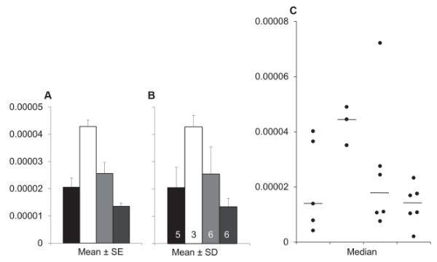

Figure 1: Bar chart (left) and Scatterplot (right) comparison (Weissgarber, et al., 2015)

Weissgarber et al expand on their findings by expressing the significance of the volume of data being analysed, summarising that the use of different classic charts should depend on the sample size and data types. The various scatterplots expressed in their study will suit smaller datasets by showing more detailed information which is typically what is required by users analysing smaller data sets, whereas analysts that are overlooking larger datasets are typically looking for trends and overarching themes as a starting point before drawing conclusions. (Weissgarber, et al., 2015)

As the data used in this HoloLens solution is expected to use larger datasets, the conclusions from the above study suggest understanding ways to use bar charts and line graphs to better display longitudinal data. Tueller et al designed a study which analyses various ways to display categorical longitudinal data, expressing the limited usefulness of growth plot graphs for such data types as it becomes confusing with larger datasets, whereas the use of horizontal line plots is considered significantly more effective at displaying trends. Additionally, the study finds that trend analysis can be significantly assisted by sorting the data into character-like groups and re-plotting the data to display similar line plots together, shown in Figure 2. They suggest this illustrates overall patterns of increasing and decreasing trajectories more clearly than the unsorted panel. (Tueller, et al., 2016)

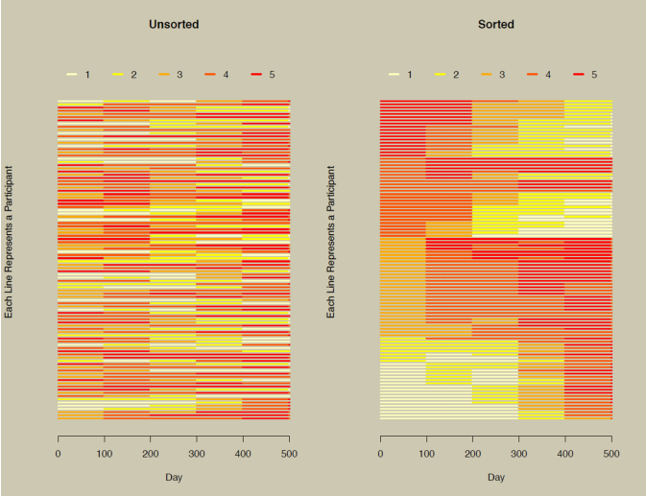

Figure 2: Unsorted (left) and sorted (right) horizontal line plots (Tueller, et al., 2016)

*AR and data visualization*

The advances of AR have opened the ability to interact with the data being analysed. Research into this area is relatively new however there are some concerns with users’ abilities with the technology at hand. Olshannikova et al explain that the understanding of new interactive environments is low in most users and so when designing both hardware and the way users interact with an interface must be considered vital when proposing solutions to visualisation of data in AR. Additionally, users must be accustomed to the data types they are being shown to reduce the intensity of the learning curve for users, they suggest that simplicity is they key in this regard. (Olshannikova, et al., 2015)

Another existing AR solution is VisAR, a prototype solution put forward by Kim et al, suggesting the use of the HoloLens for interacting with static charts can increase the productivity of data analysis. This solution uses the placement of existing charts onto a surface such as a whiteboard and can be interacted with by both gesturing and speech. This solution provides an increased interactive solution to two-dimensional data visualisations and concludes that the use of AR in this regard increases the user engagement when working with data visualisation. (Kim, et al., 2017)

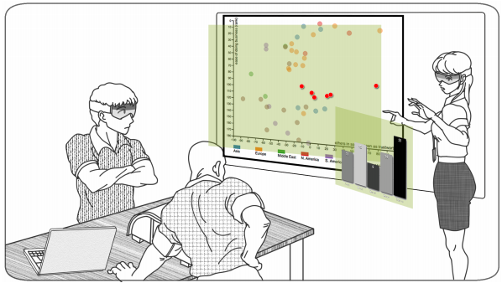

Figure 3: VisAR representation of an AR solution prototype (Kim, et al., 2017)

**Methodology**

*Using the HoloLens*

Microsoft provides a HoloLens SDK for Unity3D, this is the development tool used to produce the solution for MR data visualisation. Additionally, the developers of the HoloLens have developed a HoloLens toolkit which provides basic gesture detection, pre-existing surface generalisation detection algorithms and HoloLens-targeted user interfaces. These provide a sufficient starting point for the solution, though do not include all of the required interfaces that would be used in the final prototype, these additions are explained later in this report. As the HoloLens is a standalone device and was only accessible periodically during the development of this solution, it was important to test the various options for emulating the solution. These include the HoloLens provided emulator which is accessible through Visual Studio as well as the Unity editor.

Each emulator has its own benefits and flaws, the Unity editor view provides quicker compile times however, this solution does not provide alternative views of the scene like that of the Visual Studio emulator. The Visual Studio solution required building the solution from Unity and running the build in Visual Studio. This provides a more comprehensive view of the emulated scene, however can take up to ten times as long to test changes. Both emulators suffer from a severe field of view issue as the HoloLens screen is not representative of the entire field of view of a person, so some testing required access to the physical device, additionally, both solutions require a virtual scene which is only visible in mesh form which can cause spatial awareness issues as well as being non-representative of real space. (Figure 4) As a result, the physical HoloLens device was used periodically to ensure the solution worked in real-world spaces.

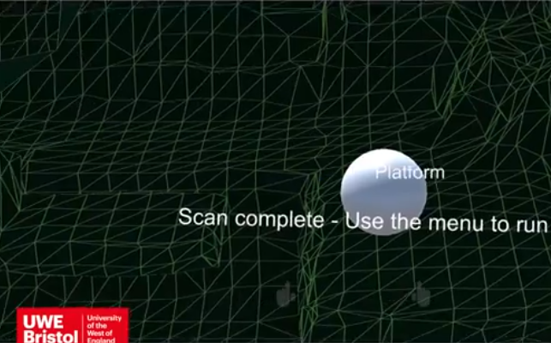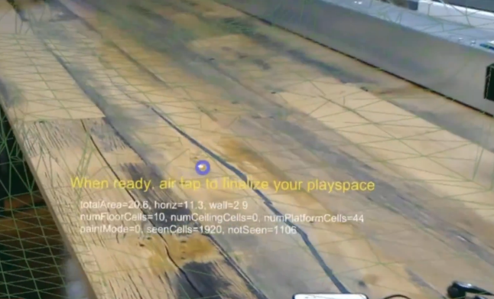

Figure 4: Emulator (top) and Device (bottom) Comparison

*Spatial Recognition and Understanding*

As previously mentioned, Microsoft provide a toolkit which provides basic HoloLens features. This toolkit includes the ability to scan surfaces and generate a mesh based on that spatial scan which can be used to place objects on surfaces. (Figure 5) This solution is robust enough as a starting point, but some alterations were required in regard to surface generalisation and the differentiating of various surfaces. The solution required the placement of objects on surfaces and this was to be either specified by the user of automatically detected when a user selects a surface to place the data. In order the generate an automated solution, the provided surface detection was not sufficient as small bumps or reflective surfaces could result in surfaces being considered different. This was resolved by creating more lenient thresholds on small changes in surface heights while ensuring the changes do not stack to account for sloped surfaces. The resulting outcome enabled uneven surfaces to be considered one flat surface which is ideal for this solution.

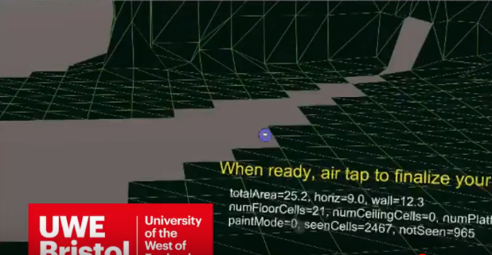

Figure 5: Simulated Mesh generation

As the HoloLens can not ensure it is in the same location from session to session, the solution requires the user to scan the area at every launch of the program. By default, the HoloLens toolkit requires a minimum number of scanned surfaces to consider a complete scan. This was not suitable for the quick testing of data and may not be required for end users of the solution. As a result, the requirements for a complete scan needed to be changed as end users of the solution will be aware of the tool and what they will require to use it. Some users may only require a small table to view their data while others will require an entire room, therefore rather than have minimum scanned surfaces, the solution only requires a surface that can be considered as a wall and any other surface to be scanned. In doing so, the user of the solution would have a wall surface to place the main User Interface (UI) and one other surface to place their data. If the resulting surfaces are not sufficient, the user can use the main UI to rescan the area. Additionally, users can enable and disable the wireframe view of the virtually generated mesh, this allows the user to know what surfaces are scanned and to ensure they are scanned with enough detail before completing the scanning process.

*Data Reading*

As the main use of this solution requires data to generate visualisations of, the reading of data is important. The solution reads the JavaScript Object Notation (JSON) file format and generates variables depending on the formatting of the JSON file. The JSON file format is chosen because of its flexibility and ability to handle high throughput and low latency without sacrificing scalability. (Yusof & Man, 2017) Although not currently robust enough for every possible result, the solution has the ability to generate entire classes from the JSON file, enabling it to read most data sets. This is generated using the dynamic expandoobject available in C#, this class is considered useful when handling nested arrays of unknown data types which is common when reading unknown data files and is therefore a key point of expansion for this solution. (Rudy, 2009) For the prototype however, the solution is targeted towards the ClairCity case studies file format (Figure 6) and specifically makes a structure based on the expected format of the ClairCIty dataset.

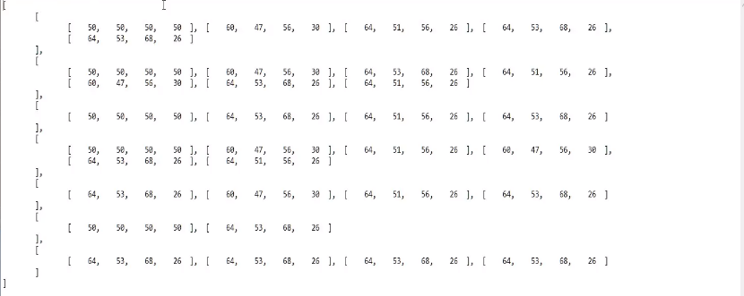

Figure 6: ClairCity Data example

*Displaying of Data*

As this research is particularly targeted towards longitudinal data, the ways in which this data can be viewed is key to the usefulness of the solution. Typically, longitudinal data is viewed through line graphs and tables, this is because they can be ordered in relation to time and then compared in length easily. It was therefore important to maintain a visual style consistently similar to those that data visualisation end users are used to experiencing while still giving additional information due to the ability to dynamically traverse the data. Therefore, the first generation of this data was to create a timeline-type visual style to display the data as if it were on a static screen in a MR environment. Figure 7 shows the timeline being displayed in a simulated environment using the aforementioned emulator. The graph is displayed using colours to differentiate the variables available from the data, displaying the highest of four values as well as the length of the lines relating to the length of time in years. The use of colours and lengths of lines to relate to these types of values is similar to that of Tueller et al and their study of alcohol dependency (Figure 8) where the colours relate to a level of dependency and the lengths of the lines relate to the number of months they took part in the study. (Tueller, et al., 2016) As at this stage, the solution is using an existing and proven format in a simulated environment this is generally as effective at visualising the data in any other platform.

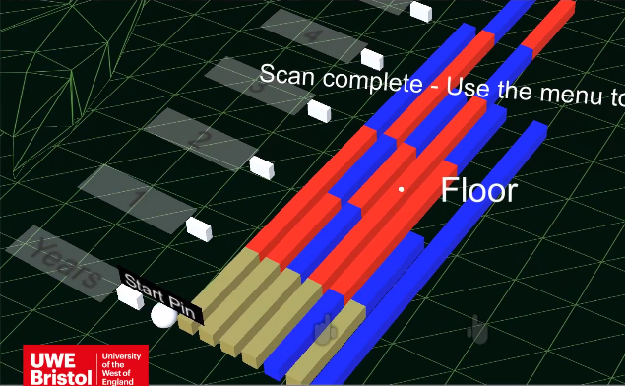

Figure 7: Longitudinal Data in HoloLens Emulator

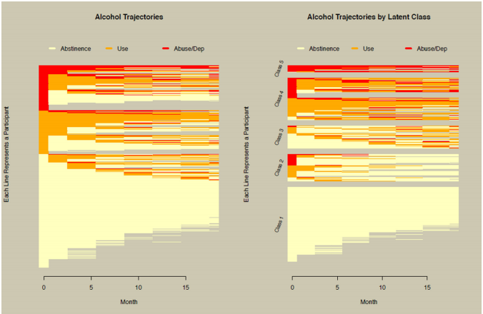

Figure 8: Representation of categorical longitudinal data using colours (Tueller, et al., 2016)

To build on existing visualisation examples, it was important to not only use the dynamic movement of the user to assist in viewing additional information but allow users to choose when information is viewed in greater detail, explained in the UI section of this report. Enabling users to traverse the data physically allows for the use of height to provide additional information. Figure 9 uses the height of specified lines to visually display values relative to the loaded data, by doing so, users can compare information without it being a large collection of numbers as well as allowing variance in detail which is not often used when viewing static data due to the additional confusion it can cause by providing too much information or requiring lots of menus to traverse. The ease of use of this feature is explained in the UI section of this report.

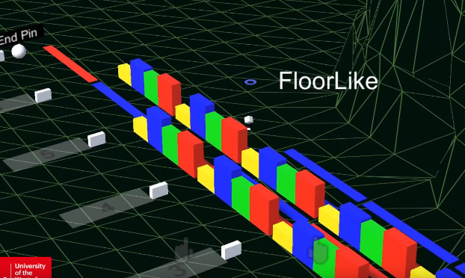

Figure 9: Additional detailed lines

Enabling the user to traverse the data physically, they are able to compare the lengths of these detailed lines from Figure 9 as well as compare the heights of the variables they wish to compare by simply moving. This type of interaction is only possible in three dimensional environments which although are possible in non-immersive displays, using a MR headset enables the users to interact with the data easier than using peripherals and interfaces such as computer mice, keyboards and games controllers to produce the same result.

*User Interface*

The development of an effective user interface enables users of the solution to interact with the visualised data in various ways. The first level of interface is the gaze-based scanning of the environment to develop the spatial map. This uses the HoloLens toolkits default gaze detection as it is robust enough to track the direction of the user and the surfaces it is interacting with. A key use of the gaze tracker is the depth detection and in doing so, the solution is able to determine the surface the user is looking at. To increase the users understanding of the surface it is looking at, the solution uses a small cube which has been oriented to the normal of the generated mesh allowing the user to know which surface is being looked at if they are looking at a corner of the mesh.

The first display the user interacts with is the main menu which allows the user to choose from a selection of options. (Figure 10) These are headed by tabs on a panel which is placed on the required wall, explained in the Spatial Recognition and Understanding section of this report. These tabs include; Data information, ordering and options. Data information relates to the data that will be loaded, in the prototype of this solution, the data loaded is overridden by the predefined ClairCity dataset, however, the menu allows users to select from any data stored in the shared assets folder of the solution. Ordering is not included in the prototype however, it will enable the ordering of the data in relation to length, average type and types of separations based on those ordering decisions. Options relates to two types of options, the first is the options for the solution which includes re-scanning the virtual mesh, toggling the showing and hiding of the virtual mesh and reloading the scene to re-orient the timeline. The other options relate to the timeline specifically, only one of these has been implemented which allows users to choose whether they place pins to mark the start and end of the area the data should be drawn in or if they wish to simply choose a surface and allow the solution to automatically generate a timeline on the surface. Other options were not in scope for this prototype as they relate to the opportunity for various data types, however, these would include; choosing colours for specific variables, choosing what time variable the timeline should relate to, toggling the global detail of the timeline and the scale and spacing of the timeline.

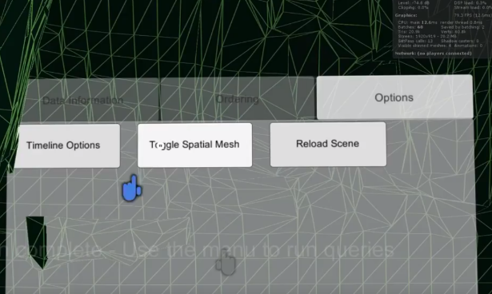

Figure 10: Main menu of the solution

The main interactions with the scene involve using the HoloLens toolkits gesture detection. There are various gestures possible with the HoloLens but to ensure users can use the solution as easily as possible, it only uses the two most commonly used gestures, air tap and drag. Air tap replaces the click you would use with a computer mouse, this is used for interacting with menus and placing the timeline as well as selecting data to toggle the details given in relation to the individual variables, explained in the Displaying of Data section of this report. In addition, the users can hover over each line on the timeline, enabling a smaller pop-up menu to appear. (Figure 11) In the solutions current prototype state, it displays the individual sections variables as well as the time-frame that the section relates to. When the user then air taps whilst hovering over the line, the small panel is pinned in place and faces the user until closed through a button input.

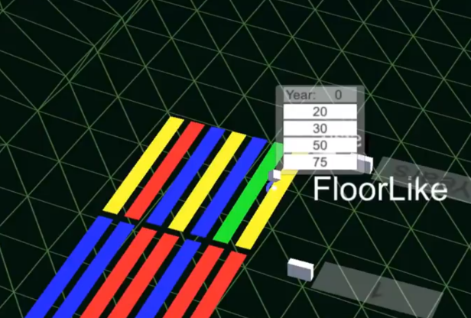

Figure 11: Smaller details panel

Unfortunately, out of scope for this project is the ability to use the drag gesture to pull lines from the timeline and place them in a new orientation, in doing so users would be able to create their own comparison areas which can be viewed as and when required and can be placed physically to the side of the other data for future reference. The solutions have been created for this in mind along with other features that are explained in the Future Possibilities portion of the Discussions section of this report.

**Discussions**

The prototype solution can display data in an MR environment using the HoloLens in an innovative way, however due to constraints of the study, some concepts were not feasible for the prototype.

One key aspect that could be expanded is the ability to interact with the data further. The data can currently be viewed in two levels of detail and compared using this detailed layout however, users may wish to separate the data through their own sorting group. This would be achieved through using the drag gesture to generate new groups of timelines which would allow the user to sort their data as they wish. Additionally, adding to the UI would allow users to be capable of quickly sorting the data when it is in its current prototype format. This would allow users to draw analytical conclusions quicker as suggested by Tueller et al’s study.

Although the solution can be considered useful, it does not currently have any formal or extensive user testing. This would be carried out by providing users with the prototype along with a static two-dimensional version of the data, users would then be required to access specific data points and note them down, whilst doing so, the users would be measure don time taken to find the data. Additionally, users would be asked which approach they found more user friendly.

The data used in the prototype is specifically targeted to the ClairCity client, however the ideal complete solution would have the capability to generate visualisations based on any dataset that a user may have. This can be made possible using the dynamic expandoobject system explained in the data reading section of this report, however this was beyond the scope of this project. In addition, the loading of any form of data would require UI changes to allow users to select the variables to align to axis of the resulting graph. Furthermore, the user would require the ability to customise the detailed view of the data as well as the colours displayed in both the detailed and non-detailed modes to allow the user to view the required data in the optimum way.

**Conclusion**

To conclude, research into existing related solutions suggests that there is a need for the development if data visualisation tools for mixed reality environments. Existing two dimensional and static solutions provide a satisfactory starting point to view data and a commonly known format; however, these can be added to provide additional information as the data we produce becomes more complex.

The prototype solution provided by this study shows the additional details that can be provided using the interactive medium of MR and the uses of variable detailed solutions. Interactivity is a positive move forward in the ability to analyse data in an effective way and to not only draw trend-based conclusions but to view data in varying complexity. Although there is room for expansion and further research in the use of MR for data visualisation, the prototype shows promise in the ability to view data in an innovative and effective way particularly relating to categorical longitudinal data.

**Funding**

The author(s) received no financial support for the research, authorship, and/or publication of this article.

**References**

Kim, T., Saket, B., Endert, A. & MacIntyre, B., 2017. *VisAR: Bringing Interactivity to Static Data Visualizations through,* s.l.: ArXiv.

Klein, G., 2006. *Visual Tracking for Augmented Reality.* 1 ed. London: University of Cambridge.

Olshannikova, E., Ometov, A., Koucheryavy, Y. & Olsson, T., 2015. Visualizing Big Data with augmented and virtual reality: challenges and research agenda. *Journal of Big Data,* 2(22), pp. 1-27.

Rudy, J., 2009. *What are the true benefits of ExpandoObject?.* [Online]   
Available at: https://stackoverflow.com/questions/1653046/what-are-the-true-benefits-of-expandoobject  
[Accessed 15 April 2018].

Shamoo, A. E. & Resnik, D. B., 2009. *Responsible Conduct of Research.* 2 ed. s.l.:Oxford Scholarship Online.

Tueller, S., Van Dorn, R. & Bobashev, G., 2016. *Visualization of Categorical Longitudinal and Times Series Data,* s.l.: Methods Rep RTI Press.

Tuliper, A., 2017. *HoloLens - Introduction to the HoloLens, Part 2: Spatial Mapping.* [Online]   
Available at: https://msdn.microsoft.com/en-us/magazine/mt745096.aspx  
[Accessed 15 April 2018].

Weissgarber, T., Milic, N., Winham, S. & Garovic, V., 2015. Beyond Bar and Line Graphs: Time for a New. *PLoS Biol,* 4(13), pp. 1-10.

Yusof, M. K. & Man, M., 2017. Efficiency of JSON for Data Retrieval in Big Data. *Indonesian Journal of Electrical Engineering and Computer Science,* 7(1), pp. 250-262.